Labwork 1
Labwork 1 – Installing MySQL and the Employees Sample Database
Course: [MI1.02a] Information Systems
Lecturer: Nghiem Thi Phuong – ICT Department, USTH
Student: Nguyễn Ngọc Châm
Student ID: 2640065

1. Objective
The goal of this labwork is to set up a working MySQL environment and load the employees sample database, which will be used in the following labs. The tasks are:
- Install MySQL Server.
- Clone the employees database from GitHub (github.com/datacharmer/test_db).
- Follow the repository instructions to install the database and verify it.
- Report every command used together with its output.

2. Environment
Item | Value
Operating system | Windows 11 Home
Database server | MySQL Community Server 8.0.46 (Windows service MySQL80)
Client tools | mysql command-line client, MySQL Workbench 8.0
Terminals | Git Bash (MSYS2 UCRT64) for git; Windows Command Prompt for mysql
Working folder | C:\Users\Lenovo\test_db

3. Steps and Results

Step 1 – Install MySQL
MySQL was installed on Windows with the official MySQL Installer (Developer Default setup type), which installs MySQL Server 8.0 and MySQL Workbench. During configuration a password was set for the root account and MySQL was registered as the Windows service MySQL80 so that it starts automatically.
To check the installation, I printed the client version and the status of the service:
Command (Command Prompt):
"C:\Program Files\MySQL\MySQL Server 8.0\bin\mysql.exe" --version
Output:
C:\Program Files\MySQL\MySQL Server 8.0\bin\mysql.exe Ver 8.0.46 for Win64 on x86_64 (MySQL Community Server - GPL)
Command (Command Prompt):
sc query MySQL80
Output:
SERVICE_NAME: MySQL80
TYPE : 10 WIN32_OWN_PROCESS
STATE : 4 RUNNING
(STOPPABLE, PAUSABLE, ACCEPTS_SHUTDOWN)
WIN32_EXIT_CODE : 0 (0x0)
SERVICE_EXIT_CODE : 0 (0x0)
Result: MySQL Server 8.0.46 is installed and the MySQL80 service is running.

Step 2 – Clone the employees database from GitHub
Commands (Git Bash):
git clone https://github.com/datacharmer/test_db
cd test_db
Output:
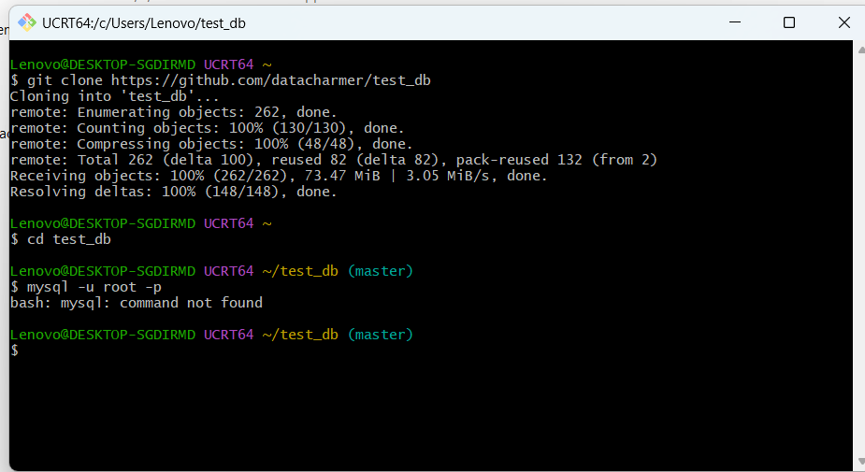
Figure 1. Cloning the test_db repository in Git Bash
Git downloaded all 262 objects (73.47 MiB) of the repository into the folder test_db. This folder contains employees.sql (the main installation script), the data dump files and the test scripts test_employees_md5.sql / test_employees_sha.sql used for verification.
Note: the command mysql -u root -p failed in Git Bash with "bash: mysql: command not found". The reason is that the MySQL bin folder is not in the PATH environment variable of Git Bash. I solved this by running the MySQL client from Windows Command Prompt with its full path (Step 3).

Step 3 – Install the employees database
Following the repository instructions, the script employees.sql is redirected into the mysql client. The script creates the database employees, creates the tables and then loads the data from the dump files.
Command (Command Prompt, inside C:\Users\Lenovo\test_db):
"C:\Program Files\MySQL\MySQL Server 8.0\bin\mysql.exe" -u root -p < employees.sql
Output:
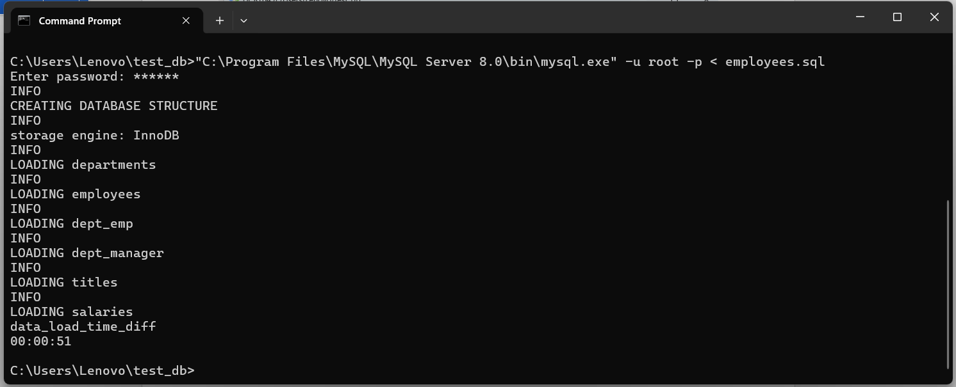
Figure 2. Loading employees.sql into MySQL
Explanation of the output:
- CREATING DATABASE STRUCTURE – the database employees and its tables were created.
- storage engine: InnoDB – the tables use the InnoDB storage engine.
- LOADING departments / employees / dept_emp / dept_manager / titles / salaries – the data of the six tables was loaded one after another.
- data_load_time_diff 00:00:51 – the whole loading process took 51 seconds and finished without any error.

Step 4 – Verify the database
4.1. Checking the structure in MySQL Workbench
After connecting to the local server (root@localhost:3306) in MySQL Workbench and refreshing the Navigator panel, the schema employees appears with all expected objects:
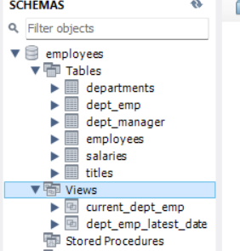
Figure 3. The employees schema in MySQL Workbench

